SUE REYNOLDS

5th GRADE SUPPLY LIST

2025-2026

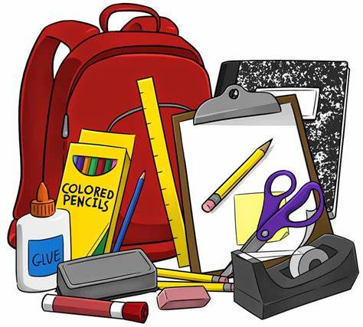

6 Marble Composition Books

3 dozen pencils

6 highlighters any colors

8 Elmer glue sticks

1 pair of scissors

2 packages of wide rule paper

3 boxes of Kleenex

6 black Expo markers

1 Container of disinfectant wipes

1 pair of headphones (no earbuds)

1 pack of copy paper

1 24 count color pencils

1 pencil pouch

